Assignment -7
Task – 1
Description:
Paste a function with a missing colon (add(a, b)), and let AI fix the syntax error.
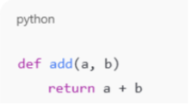

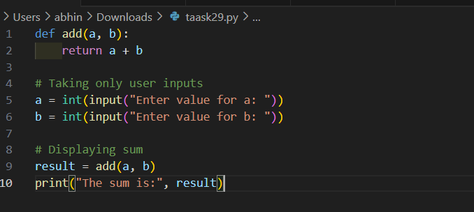
Expected Output: Corrected function with syntax fix
Practical Output:

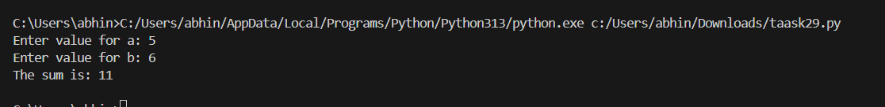

Task – 2:
Description: (Loops)
Identify and fix a logic error in a loop that causes infinite iteration.
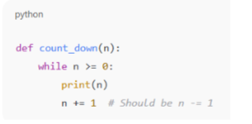

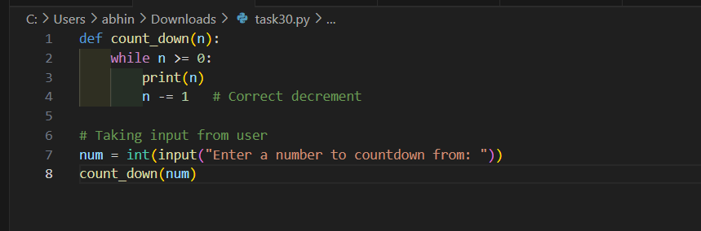
Expected Output: AI fixes increment/decrement error.
Practical Output:

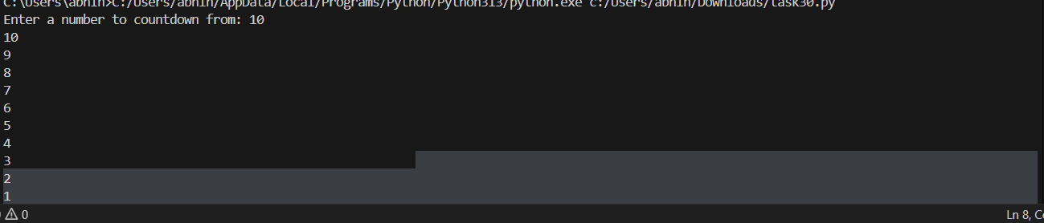

Task – 3
Description: Debug a runtime error caused by division by zero. Let AI insert try-except.
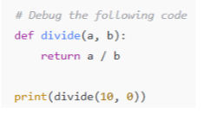

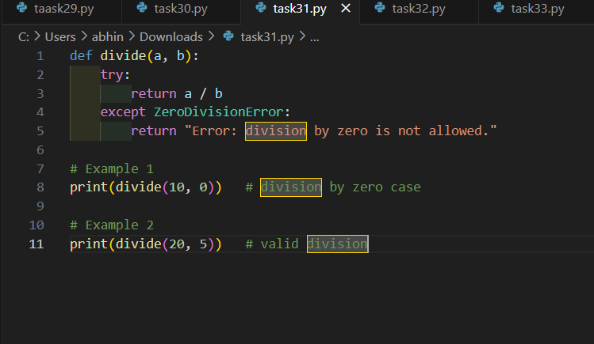
Expected Output: Corrected function with safe error handling.
Practical Output:

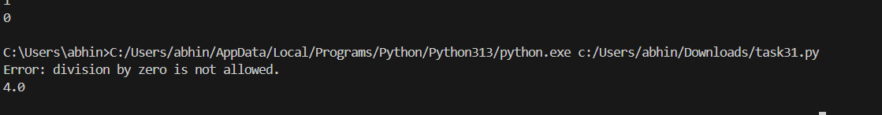

Task – 4
Description:
Provide a faulty class definition (missing self in parameters). Let AI fix it.
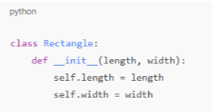

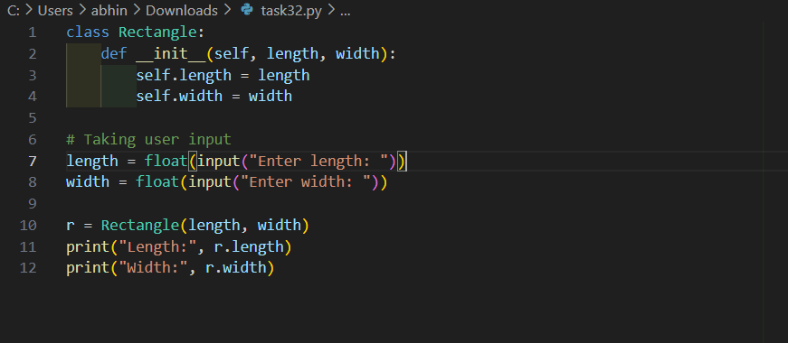
Expected Output: Correct __init__() method and explanation.
Practical Output:

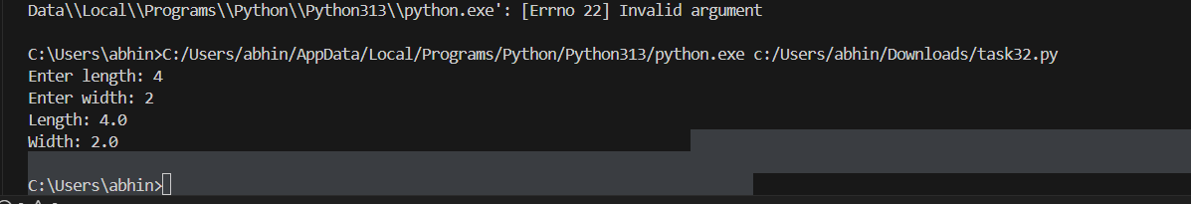

Task – 5
Description:
Access an invalid list index and use AI to resolve the Index Error.
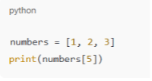

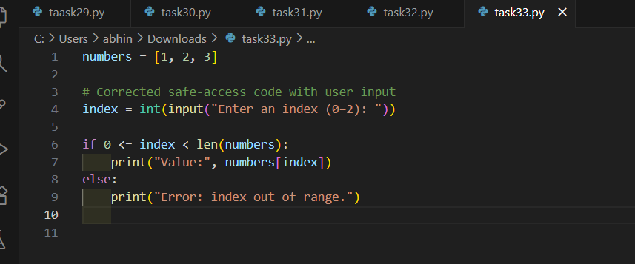
Expected Output: AI suggests checking length or using safe access logic.
Practical Output:

